Title: Food Ordering And Delivery Management System  
**Course:** DATABASE MANAGEMENT SYSTEM (UE23CS351A)  
**Project Level:** Experiential Learning: Level 2 (Mini Project)  
**Team Members:**

* Student 1: SIRI S ARADHYA — PES1UG23CS906
* Student 2: YOGITHA A S — PES1UG23CS901

## **Institution:** PES University **Submission Date:** 1st NOV 20205

## **DESCRIPTION**

**Abstract**: This project implements a Food Ordering System using MySQL as backend and Streamlit as the frontend. The system supports user registration/login (hashed passwords), restaurant browsing, menu management, cart functionality, order placement (stored procedure), automatic inventory updates (triggers), payment tracking, and user reviews. The application demonstrates normalized relational design, stored procedures, triggers, functions, and analytical queries—meeting the DBMS mini-project requirements.

## **User Requirement Specification**

**2.1 Purpose of the Project**

The purpose of this project is to design and develop a Food Ordering System that enables users to browse restaurants, view menus, place orders, and provide feedback, while allowing administrators to manage restaurants, menu items, and customer orders efficiently.

This project aims to simulate the functionality of popular food delivery platforms like Swiggy or Zomato, providing an interactive web-based platform integrated with a relational database. It demonstrates how database concepts such as normalization, referential integrity, stored procedures, and triggers can be implemented effectively in a real-world business scenario.

The system provides an end-to-end food ordering experience — from restaurant browsing and cart management to order placement and payment tracking — all supported by robust backend database operations.

**2.2 Scope of the Project**

The scope of this project covers both user-facing and administrator-facing functionalities.

* **For Users:**  
  The system allows registration and secure login using password hashing, browsing multiple restaurants and their menus, adding desired food items to a cart, placing orders, selecting payment methods, and submitting reviews with ratings.
* **For Administrators:**  
  The system provides a dashboard to manage restaurants, update or delete menu items, track order progress, and update order statuses.

The project ensures data consistency and automation using triggers, procedures, and functions. It demonstrates complete CRUD (Create, Read, Update, Delete) operations across all entities and enforces business rules such as inventory control and order status history.

This application is scalable and can be extended further with delivery tracking, user analytics, and coupon-based discount systems, making it a comprehensive database-driven business solution.

**2.3 Detailed Description of the Project**

The Food Ordering System is implemented using MySQL as the backend database and Streamlit (Python) as the frontend interface.  
It integrates multiple interrelated tables that represent real-world entities such as users, restaurants, menu items, orders, payments, and reviews.

* The database schema includes tables: Users, Restaurants, Menu, Orders, Order_Items, Cart, Payments, Coupons, Delivery_Partners, Reviews, and Order_Status_History.
* The database is normalized and uses foreign key constraints to maintain referential integrity among entities.
* Stored Procedures automate key operations such as order placement and review submission (PlaceOrderFromCart, AddReview).
* Functions such as GetOrderTotal and GetRestaurantAvgRating help compute derived data for business insights.
* Triggers handle automatic updates — adjusting stock levels after each order, recalculating totals, and maintaining a detailed log of order status changes.
* The Streamlit frontend provides a graphical user interface with interactive features for both customers and administrators. Users can browse restaurants with images, view menu categories, and interactively manage their cart, while admins can view and update data seamlessly.

The system thus demonstrates a complete data flow from front-end operations to backend database transactions, ensuring accuracy, security, and ease of management.

**2.4 Functional Requirements**

|  |  |  |
| --- | --- | --- |
| Sl. No. | System Functionality | Description |
| 1 | **User Registration & Login** | Allows users to sign up with name, email, and password. Passwords are hashed using SHA-256 for secure authentication. |
| 2 | **Restaurant Browsing** | Displays a list of restaurants with details and images. Users can select a restaurant to view its menu. |
| 3 | **Menu Display & Filtering** | Fetches menu items dynamically from the database and categorizes them (e.g., Pizza, Drinks, Desserts). |
| 4 | **Add to Cart** | Enables users to add menu items to their cart with a specified quantity. Duplicate entries are restricted by unique constraints. |
| 5 | **View / Modify Cart** | Displays all items in the user’s cart with quantities, prices, and totals. Allows removal of items. |
| 6 | **Place Order** | Executes stored procedure PlaceOrderFromCart to create an order, move items from the cart, and compute total amount. |
| 7 | **Payment Processing** | Updates payment details (method and amount) for each order. Supports Credit Card, Debit Card, UPI, Wallet, and Cash. |
| 8 | **Automatic Stock Update (Trigger)** | Triggers automatically adjust Menu.stock when items are ordered or deleted. Prevents negative stock levels. |
| 9 | **Order Status Tracking** | Order statuses are updated by users/admins. A trigger logs every change in Order_Status_History. |
| 10 | **Review Submission** | Users can submit ratings and comments through the AddReview procedure. Validation ensures ratings between 1 and 5. |
| 11 | **Admin Dashboard** | Admins can add/delete restaurants, manage menu items, and update order statuses from a single interface. |
| 12 | **Coupon Management** | Coupon codes provide percentage-based discounts with validation of expiry date and max discount amount. |
| 13 | **Data Analytics & Insights** | Functions and queries provide insights such as average restaurant ratings. |
| 14 | **Security & Integrity** | The system ensures data consistency through foreign keys, constraints, and controlled SQL operations in the application layer. |

**2.5 ER Diagram and Representation Schema**

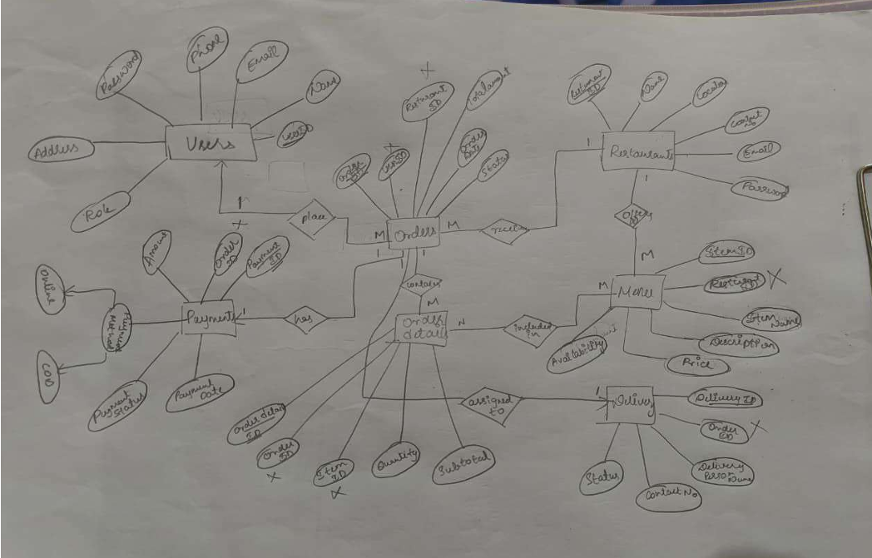

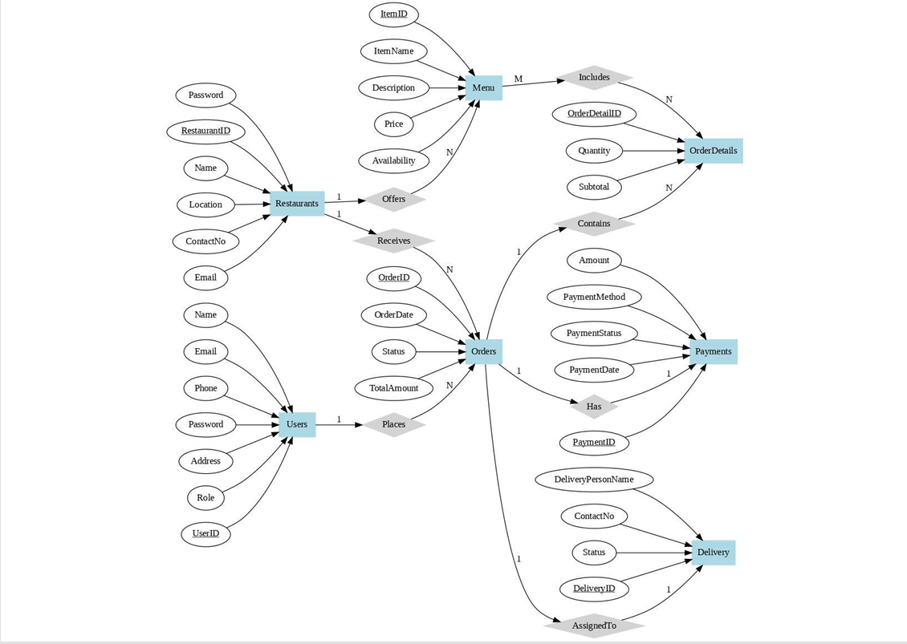

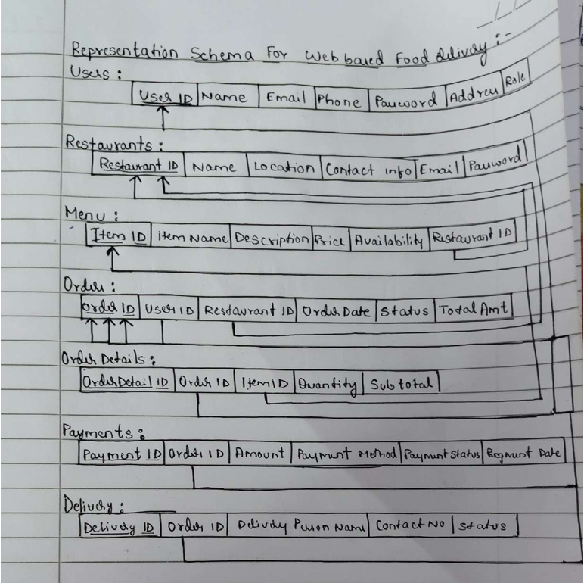

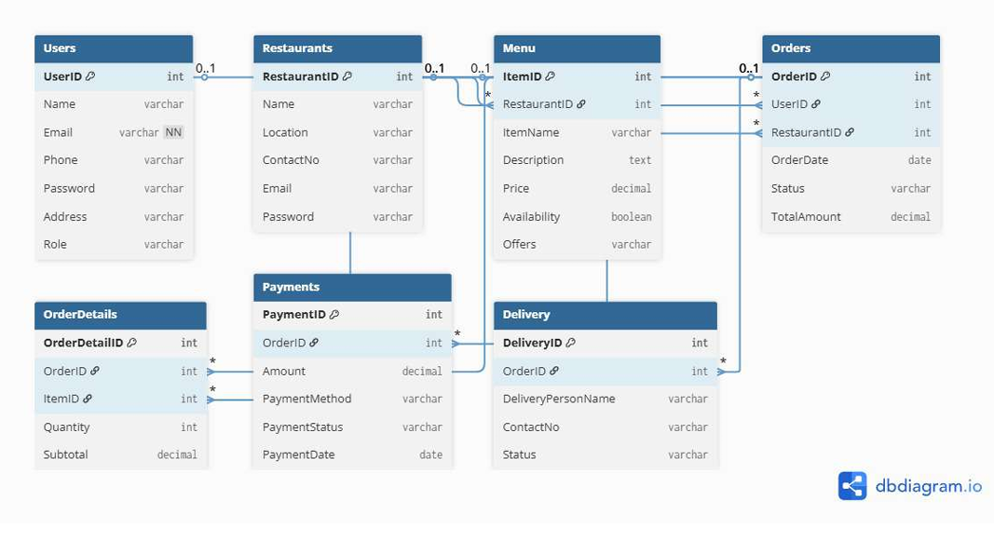

## List of Softwares/Tools/Programming languages used

|  |  |  |
| --- | --- | --- |
| Sl. No. | Software / Tool / Language | Purpose / Description |
| 1 | **MySQL 8.0** | Backend relational database used to create tables, relationships, triggers, procedures, and functions. |
| 2 | **MySQL Workbench** | Tool for database design, ER diagram creation, query execution, and schema visualization. |
| 3 | **Python 3.x** | Primary programming language used for backend logic and database integration. |
| 4 | **Streamlit** | Web-based frontend framework used to develop the user interface for both users and admins. |
| 5 | **mysql-connector-python** | Python library used to connect the Streamlit application with the MySQL database. |
| 6 | **pandas** | Python library used for handling and displaying database query results in tabular form. |
| 7 | **Pillow (PIL)** | Library used for image handling and display in the Streamlit UI. |
| 8 | **Git & GitHub** | Version control and repository hosting platform for maintaining project code and documentation. |
| 9 | **VS Code** | Integrated development environments (IDEs) used for writing and debugging Python and SQL code. |
| 10 | **Windows 10** | Operating system used for project development and testing environment. |

## DDL Commands

-- DATABASE

DROP DATABASE IF EXISTS FoodOrdering;

CREATE DATABASE FoodOrdering;

USE FoodOrdering;

-- USERS

CREATE TABLE Users (

user_id INT AUTO_INCREMENT PRIMARY KEY,

name VARCHAR(100) NOT NULL,

email VARCHAR(100) UNIQUE NOT NULL,

phone VARCHAR(20),

address VARCHAR(255),

password VARCHAR(255),

created_at DATETIME DEFAULT CURRENT_TIMESTAMP,

updated_at DATETIME DEFAULT CURRENT_TIMESTAMP ON UPDATE CURRENT_TIMESTAMP

);

-- RESTAURANTS

CREATE TABLE Restaurants (

restaurant_id INT AUTO_INCREMENT PRIMARY KEY,

name VARCHAR(100) NOT NULL,

address VARCHAR(255),

phone VARCHAR(20),

created_at DATETIME DEFAULT CURRENT_TIMESTAMP,

updated_at DATETIME DEFAULT CURRENT_TIMESTAMP ON UPDATE CURRENT_TIMESTAMP

);

-- DELIVERY PARTNERS

CREATE TABLE Delivery_Partners (

delivery_partner_id INT AUTO_INCREMENT PRIMARY KEY,

name VARCHAR(100),

phone VARCHAR(20),

created_at DATETIME DEFAULT CURRENT_TIMESTAMP,

updated_at DATETIME DEFAULT CURRENT_TIMESTAMP ON UPDATE CURRENT_TIMESTAMP

);

-- MENU

CREATE TABLE Menu (

menu_id INT AUTO_INCREMENT PRIMARY KEY,

restaurant_id INT NOT NULL,

name VARCHAR(100) NOT NULL,

price DECIMAL(8,2) NOT NULL,

category VARCHAR(50),

stock INT DEFAULT 100,

created_at DATETIME DEFAULT CURRENT_TIMESTAMP,

updated_at DATETIME DEFAULT CURRENT_TIMESTAMP ON UPDATE CURRENT_TIMESTAMP,

FOREIGN KEY (restaurant_id) REFERENCES Restaurants(restaurant_id)

);

-- ORDERS

CREATE TABLE Orders (

order_id INT AUTO_INCREMENT PRIMARY KEY,

user_id INT NOT NULL,

order_date DATETIME DEFAULT CURRENT_TIMESTAMP,

total_amount DECIMAL(10,2) DEFAULT 0.00,

status ENUM('Pending', 'Confirmed', 'Out for Delivery', 'Delivered', 'Cancelled') DEFAULT 'Pending',

delivery_partner_id INT DEFAULT NULL,

coupon_code VARCHAR(50),

created_at DATETIME DEFAULT CURRENT_TIMESTAMP,

updated_at DATETIME DEFAULT CURRENT_TIMESTAMP ON UPDATE CURRENT_TIMESTAMP,

FOREIGN KEY (user_id) REFERENCES Users(user_id),

FOREIGN KEY (delivery_partner_id) REFERENCES Delivery_Partners(delivery_partner_id)

);

-- ORDER ITEMS

CREATE TABLE Order_Items (

order_item_id INT AUTO_INCREMENT PRIMARY KEY,

order_id INT NOT NULL,

menu_id INT NOT NULL,

quantity INT DEFAULT 1,

created_at DATETIME DEFAULT CURRENT_TIMESTAMP,

updated_at DATETIME DEFAULT CURRENT_TIMESTAMP ON UPDATE CURRENT_TIMESTAMP,

FOREIGN KEY (order_id) REFERENCES Orders(order_id),

FOREIGN KEY (menu_id) REFERENCES Menu(menu_id),

CHECK (quantity > 0)

);

-- CART

CREATE TABLE Cart (

cart_id INT AUTO_INCREMENT PRIMARY KEY,

user_id INT NOT NULL,

menu_id INT NOT NULL,

quantity INT DEFAULT 1,

created_at DATETIME DEFAULT CURRENT_TIMESTAMP,

updated_at DATETIME DEFAULT CURRENT_TIMESTAMP ON UPDATE CURRENT_TIMESTAMP,

FOREIGN KEY (user_id) REFERENCES Users(user_id),

FOREIGN KEY (menu_id) REFERENCES Menu(menu_id),

UNIQUE KEY uniq_user_menu (user_id, menu_id),

CHECK (quantity > 0)

);

-- REVIEWS

CREATE TABLE Reviews (

review_id INT AUTO_INCREMENT PRIMARY KEY,

user_id INT NOT NULL,

restaurant_id INT NOT NULL,

rating INT NOT NULL CHECK (rating BETWEEN 1 AND 5),

comment VARCHAR(500),

review_date DATETIME DEFAULT CURRENT_TIMESTAMP,

created_at DATETIME DEFAULT CURRENT_TIMESTAMP,

updated_at DATETIME DEFAULT CURRENT_TIMESTAMP ON UPDATE CURRENT_TIMESTAMP,

FOREIGN KEY (user_id) REFERENCES Users(user_id),

FOREIGN KEY (restaurant_id) REFERENCES Restaurants(restaurant_id)

);

-- PAYMENTS

CREATE TABLE Payments (

payment_id INT AUTO_INCREMENT PRIMARY KEY,

order_id INT NOT NULL,

payment_date DATETIME DEFAULT CURRENT_TIMESTAMP,

amount DECIMAL(10,2),

method VARCHAR(50),

status ENUM('Pending', 'Completed', 'Failed') DEFAULT 'Pending',

created_at DATETIME DEFAULT CURRENT_TIMESTAMP,

updated_at DATETIME DEFAULT CURRENT_TIMESTAMP ON UPDATE CURRENT_TIMESTAMP,

FOREIGN KEY (order_id) REFERENCES Orders(order_id)

);

-- ORDER STATUS HISTORY

CREATE TABLE Order_Status_History (

history_id INT AUTO_INCREMENT PRIMARY KEY,

order_id INT NOT NULL,

old_status VARCHAR(50),

new_status VARCHAR(50),

changed_at DATETIME DEFAULT CURRENT_TIMESTAMP,

changed_by VARCHAR(100) DEFAULT 'system',

FOREIGN KEY (order_id) REFERENCES Orders(order_id)

);

-- COUPONS

CREATE TABLE Coupons (

coupon_id INT AUTO_INCREMENT PRIMARY KEY,

code VARCHAR(50) UNIQUE,

discount_percent INT CHECK (discount_percent BETWEEN 0 AND 100),

max_discount_amount DECIMAL(10,2),

expiry_date DATE,

active BOOLEAN DEFAULT TRUE,

created_at DATETIME DEFAULT CURRENT_TIMESTAMP

);

## CRUD Operations

**INSERT:**

SHOW TABLES;

SELECT * FROM Users LIMIT 5;

SELECT * FROM Restaurants LIMIT 5;

SELECT * FROM Menu LIMIT 10;

SELECT * FROM Orders LIMIT 10;

SELECT * FROM Order_Items LIMIT 10;

SELECT * FROM Cart LIMIT 10;

SELECT * FROM Payments LIMIT 10;

SELECT * FROM Reviews LIMIT 10;

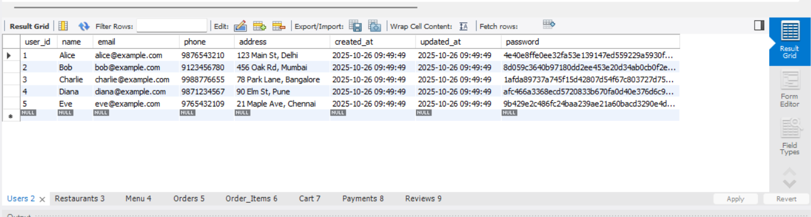

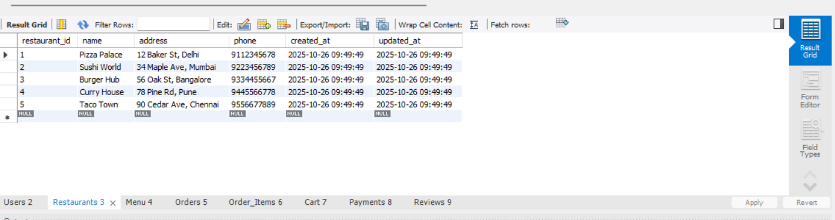

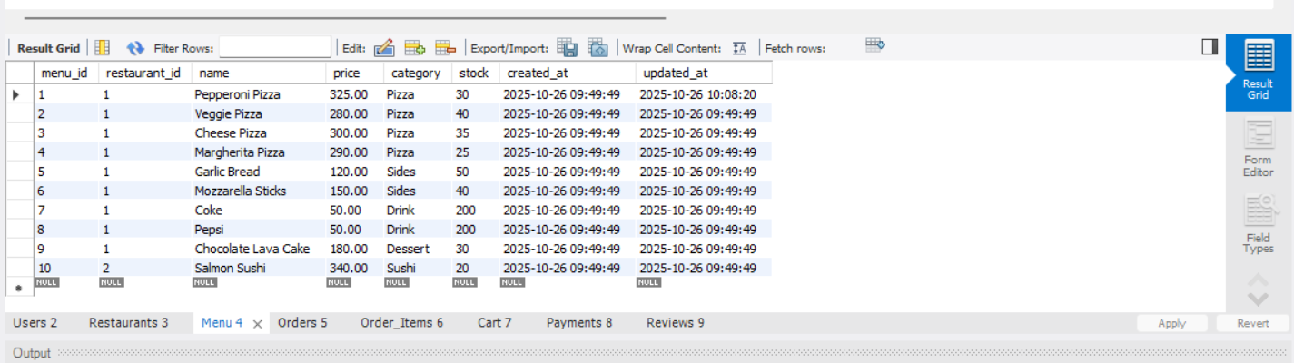

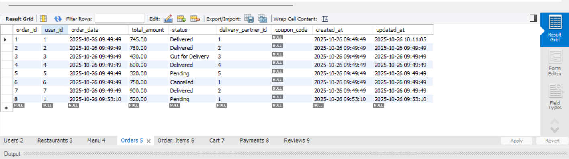

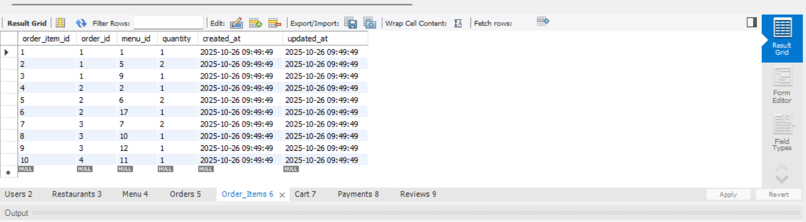

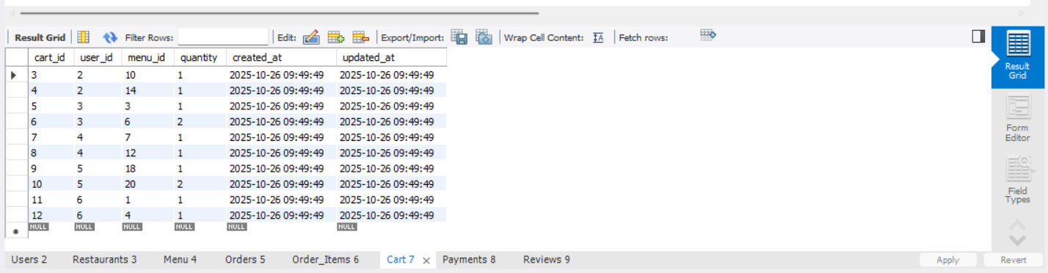

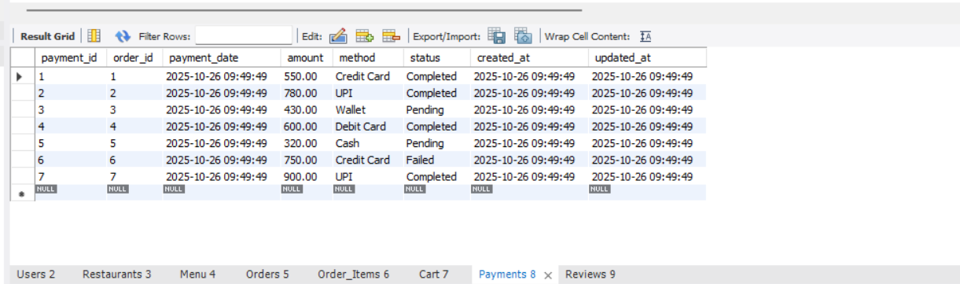

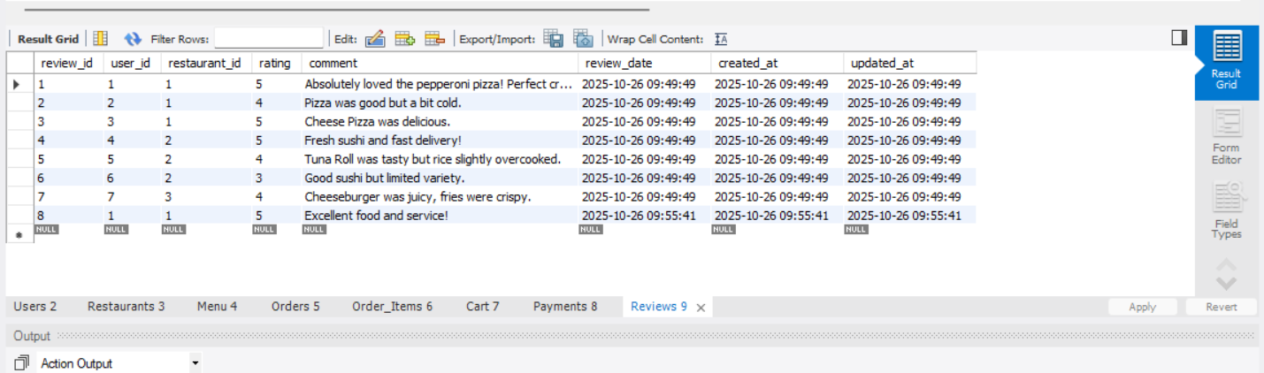

**UPDATE:**

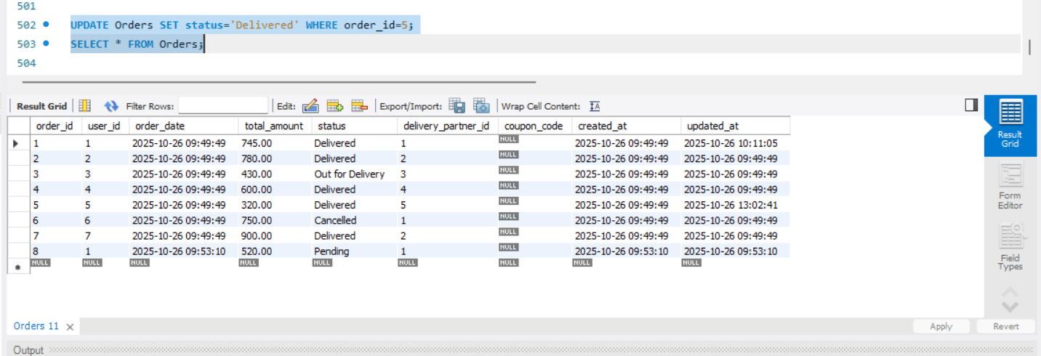

**DELETE:**

DELETE FROM Cart WHERE user_id=1 AND menu_id=2;

## List of functionalities/features of the application and its associated screenshots using front end

**USER PORTAL**

SIGNUP

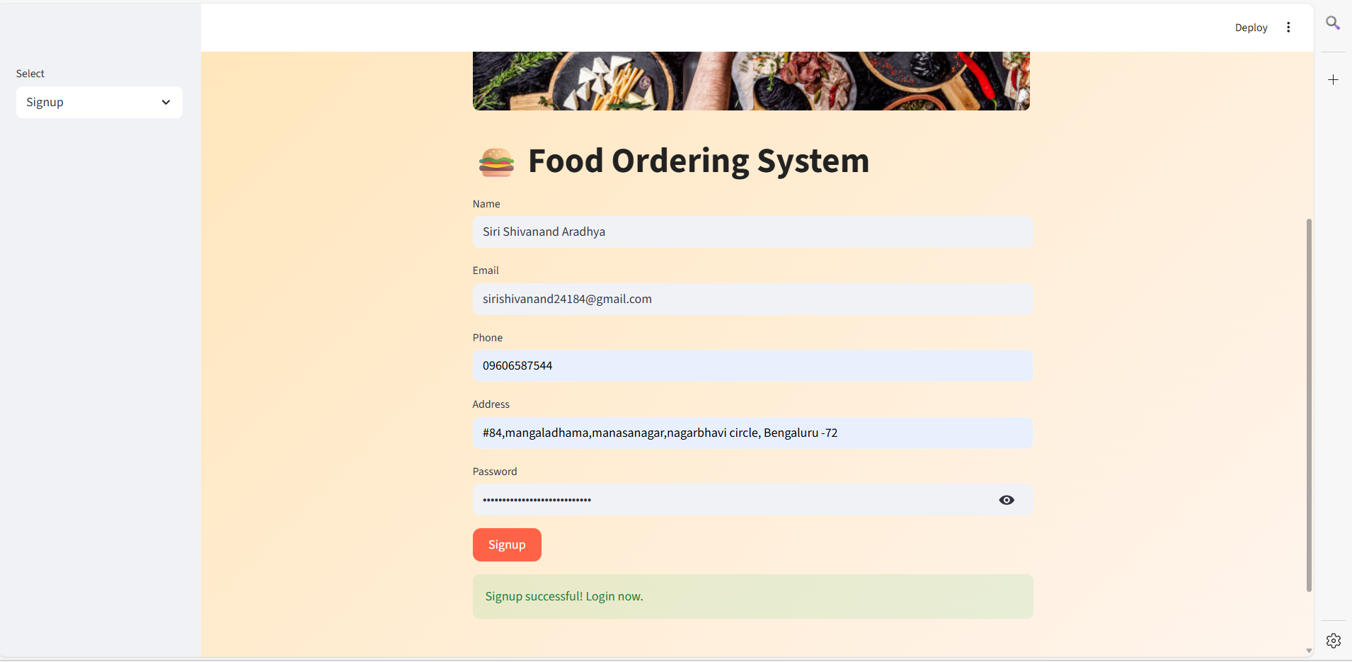

LOGIN

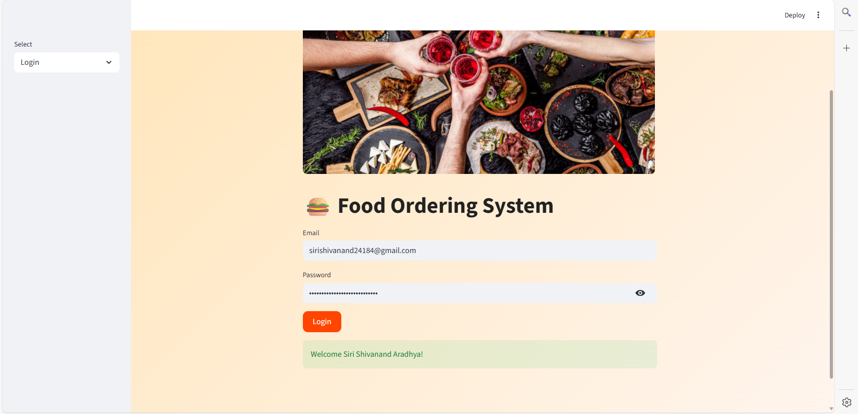

BROWSE RESTAURANT

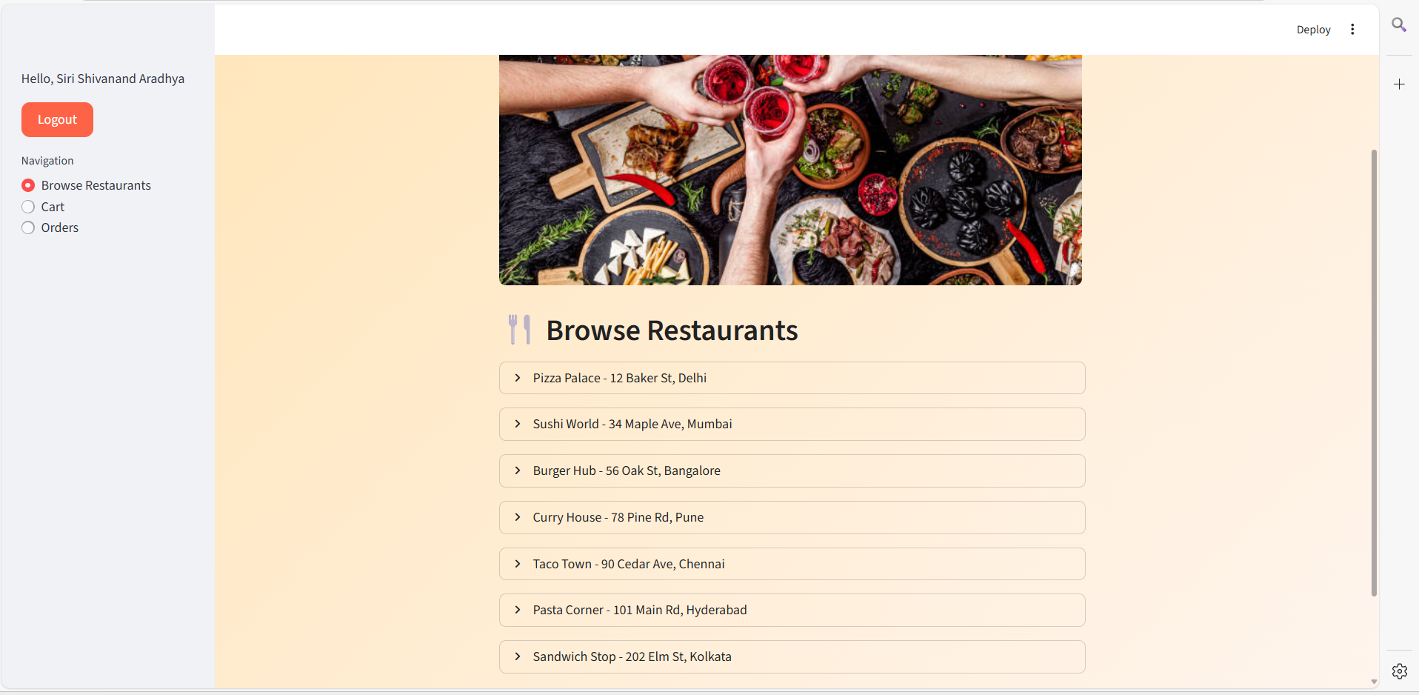

ADD TO CART

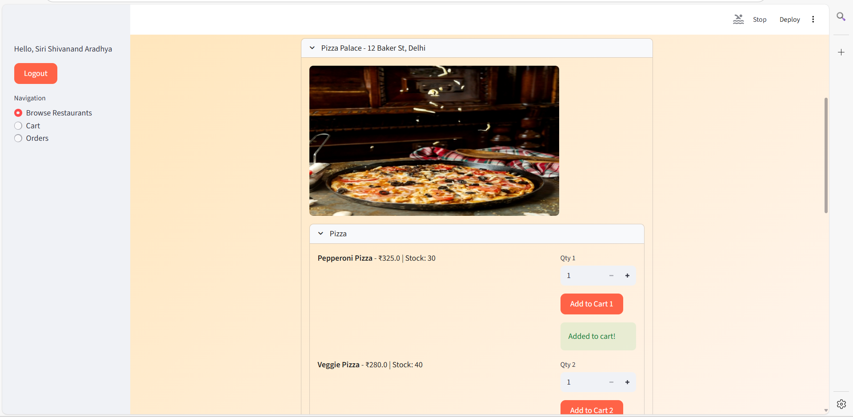

REMOVE FROM CART OR PLACE ORDER

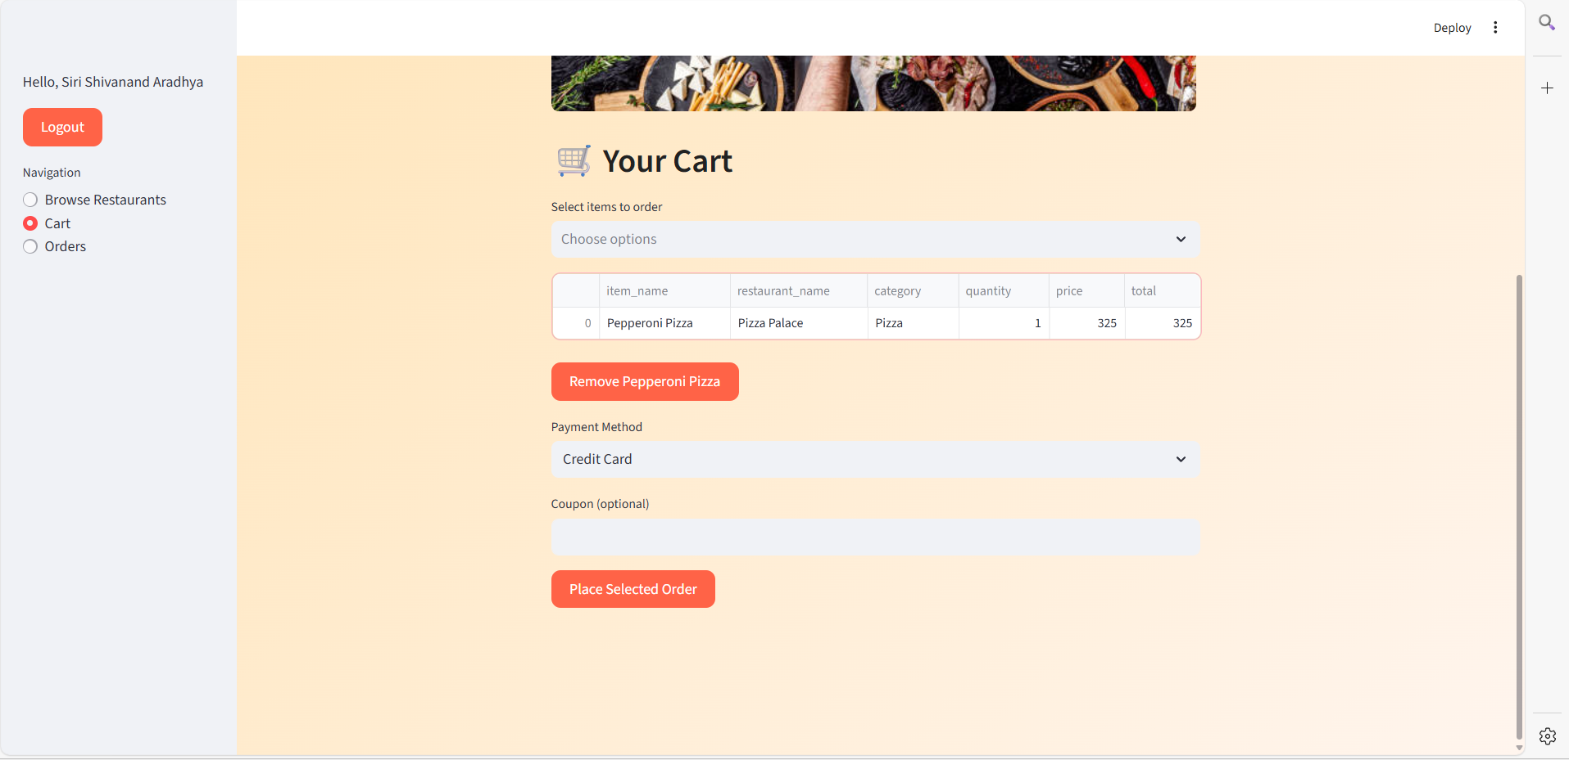

VIEW ORDER HISTORY AND VIEW ORDER STATUS :

RATE AND REVIEW RESTAURANTS AND CANCEL ORDER:

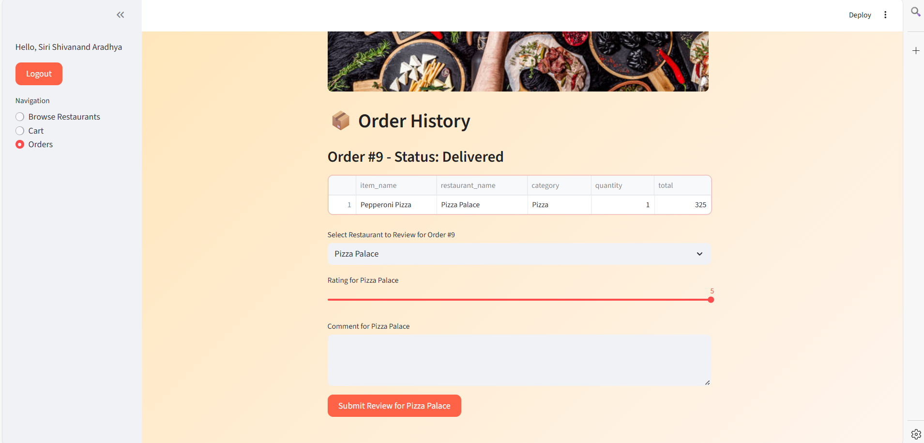

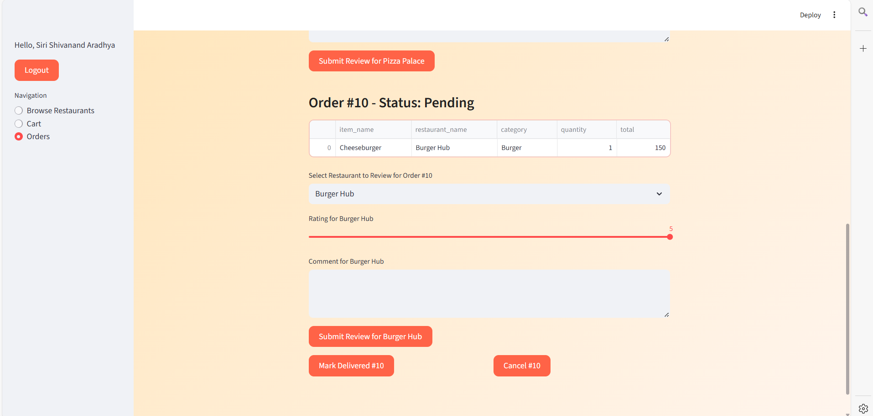

**ADMIN PORTAL**

LOGIN:

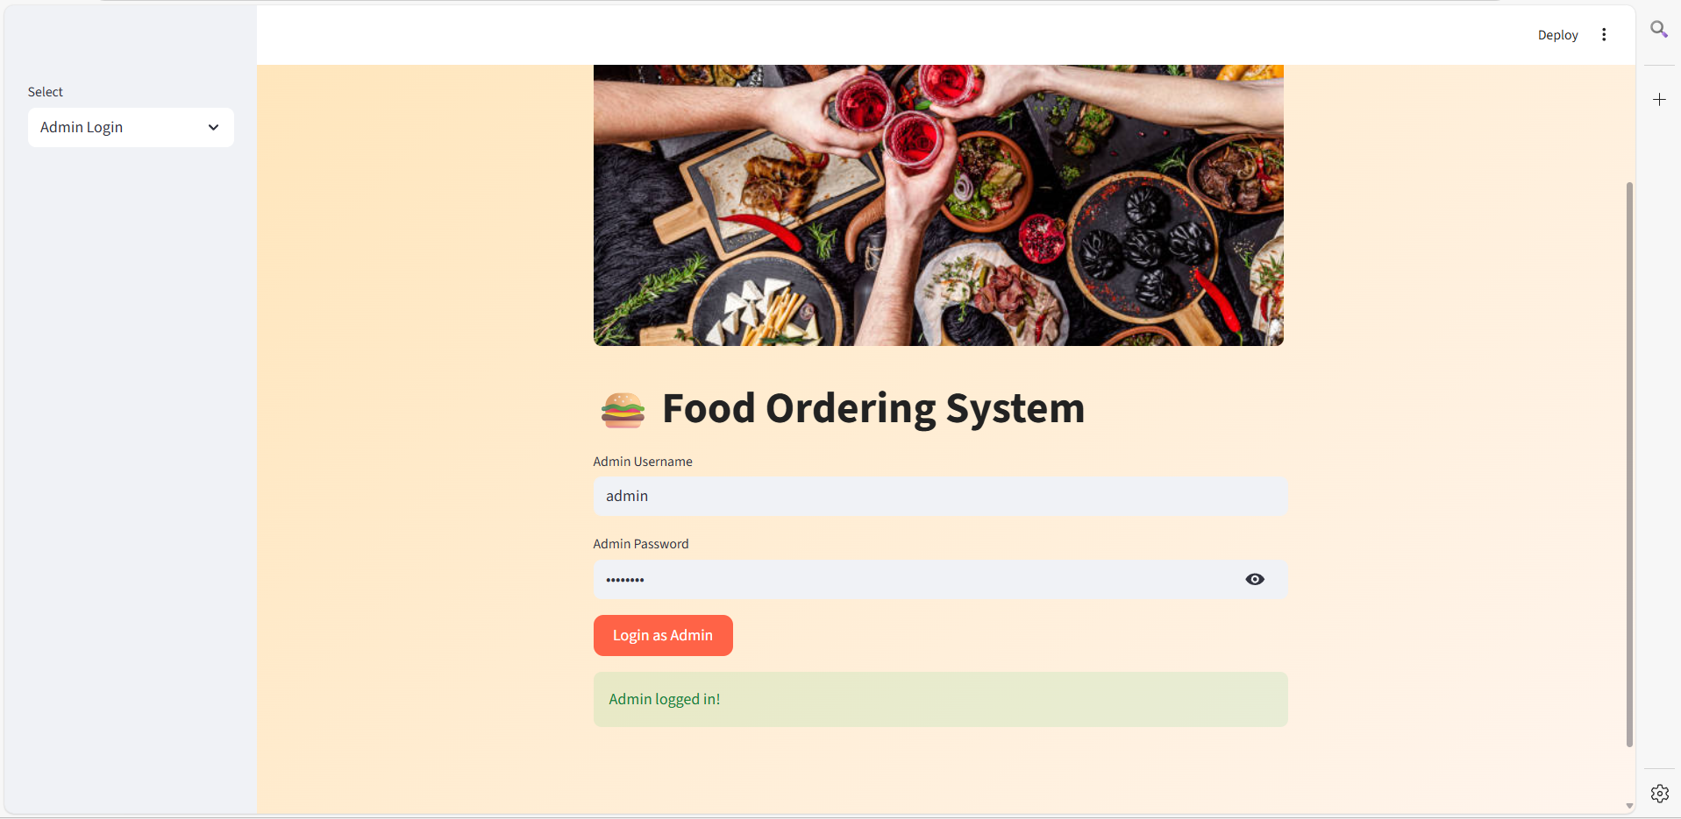

MANAGE RESTAURANTS – ADD/DELETE

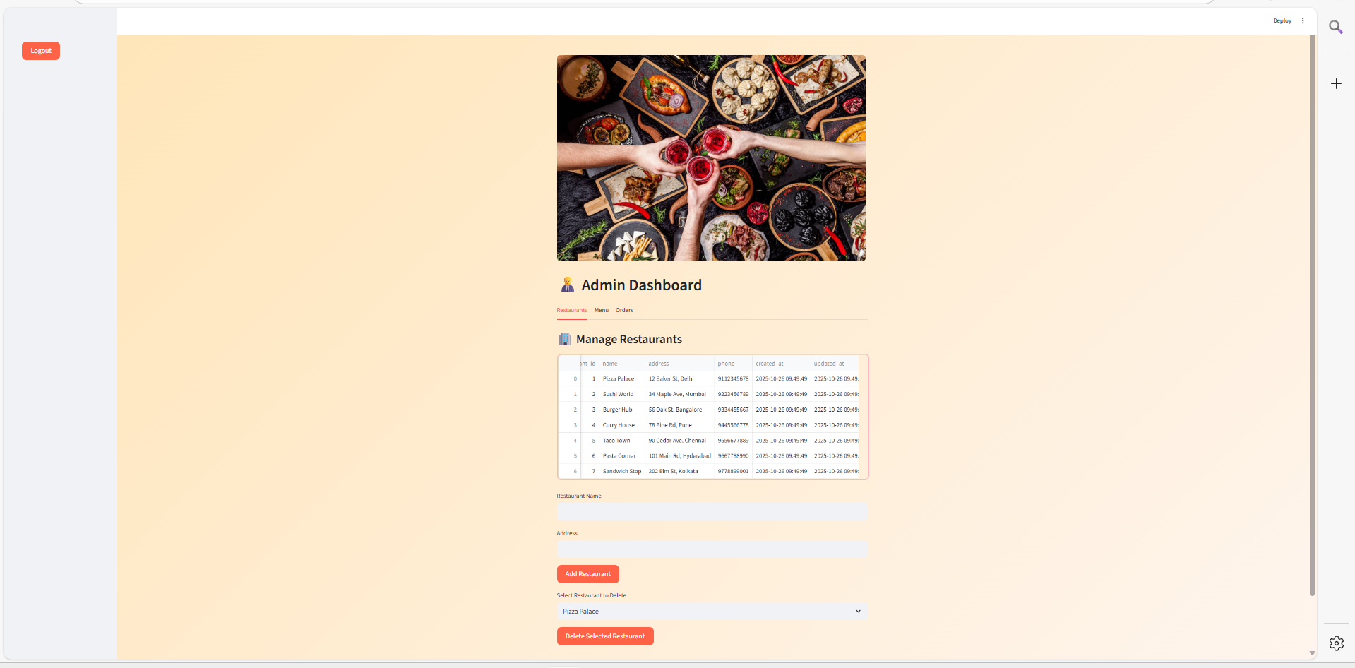

ADD, DELETE, UPDATE MENU ITEMS:

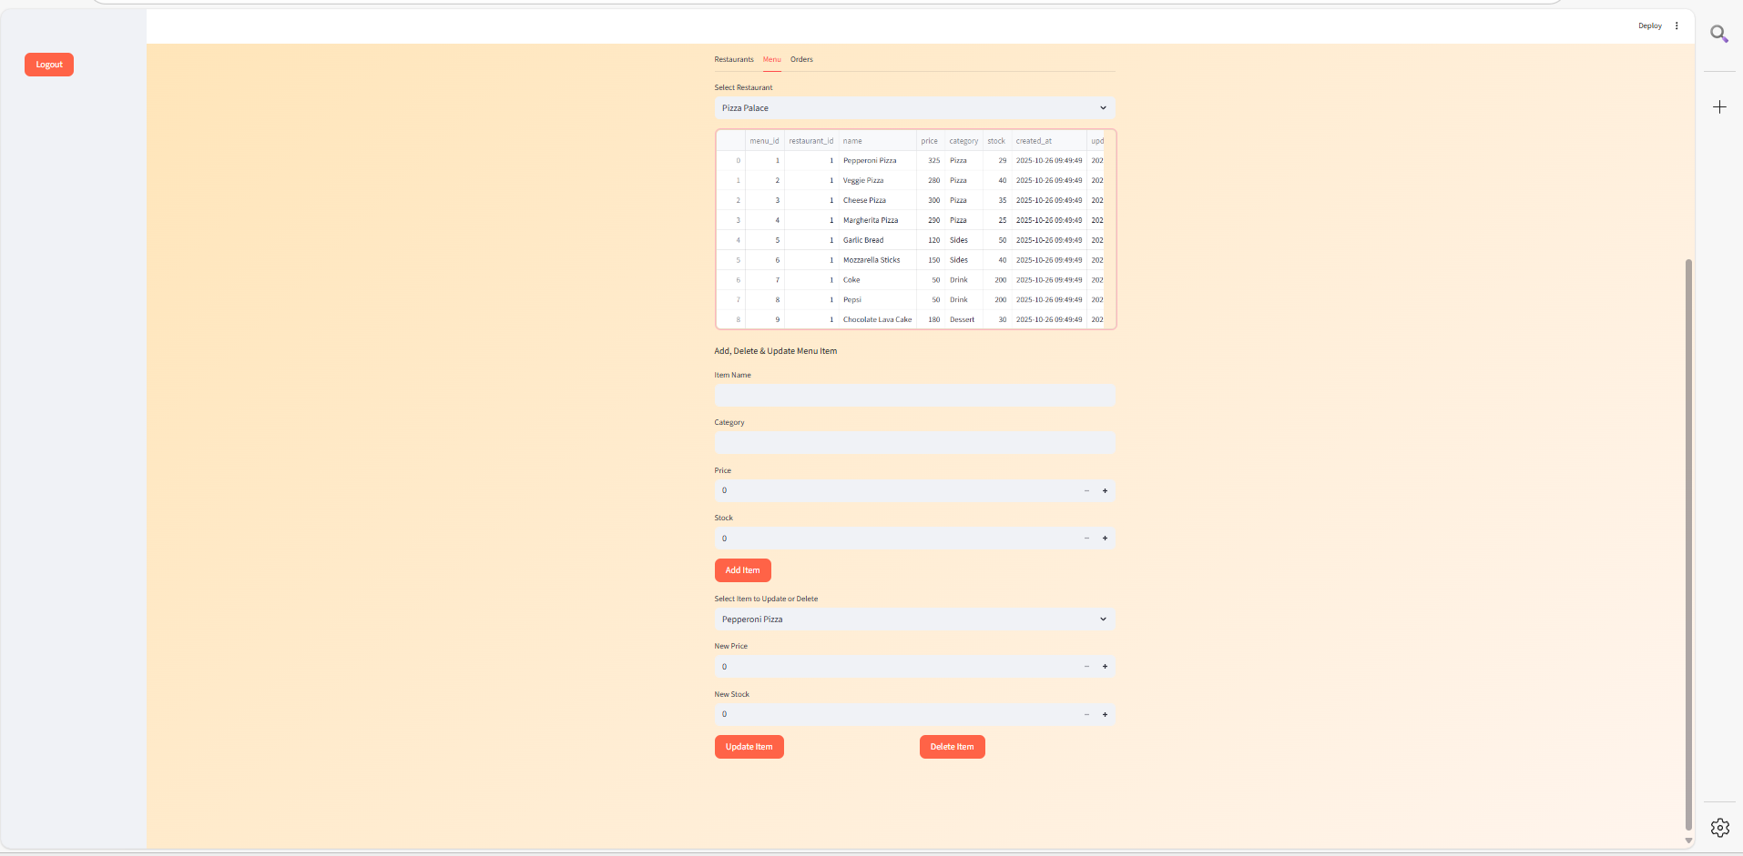

ORDER MANAGEMENT

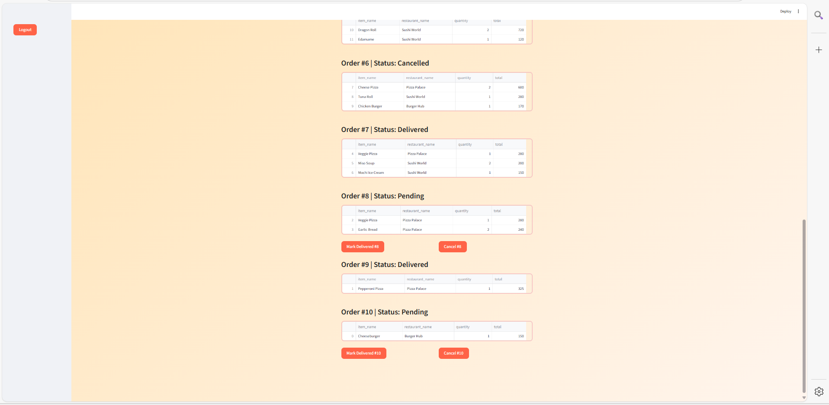

## Triggers, Procedures/Functions, Nested query, Join, Aggregate queries

**FUNCTIONS**

DELIMITER //

CREATE FUNCTION GetOrderTotal(p_order_id INT)

RETURNS DECIMAL(10,2)

DETERMINISTIC

BEGIN

DECLARE total DECIMAL(10,2) DEFAULT 0.00;

SELECT IFNULL(SUM(m.price * oi.quantity), 0.00) INTO total

FROM Order_Items oi

JOIN Menu m ON oi.menu_id = m.menu_id

WHERE oi.order_id = p_order_id;

RETURN total;

END;

//

CREATE FUNCTION GetRestaurantAvgRating(p_restaurant_id INT)

RETURNS DECIMAL(3,2)

DETERMINISTIC

BEGIN

DECLARE avg_rating DECIMAL(3,2);

SELECT IFNULL(AVG(rating), 0.00) INTO avg_rating

FROM Reviews

WHERE restaurant_id = p_restaurant_id;

RETURN avg_rating;

END;

//

DELIMITER ;

-- Invoking Functions

SELECT GetOrderTotal(1) AS OrderTotal;

SELECT GetRestaurantAvgRating(1) AS AverageRating;

**PROCEDURE**

DELIMITER //

CREATE PROCEDURE PlaceOrderFromCart(IN p_user_id INT, IN p_delivery_partner_id INT)

BEGIN

DECLARE v_order_id INT;

INSERT INTO Orders (user_id, total_amount, status, delivery_partner_id)

VALUES (p_user_id, 0.00, 'Pending', p_delivery_partner_id);

SET v_order_id = LAST_INSERT_ID();

INSERT INTO Order_Items (order_id, menu_id, quantity)

SELECT v_order_id, menu_id, quantity FROM Cart WHERE user_id = p_user_id;

UPDATE Orders

SET total_amount = GetOrderTotal(v_order_id)

WHERE order_id = v_order_id;

DELETE FROM Cart WHERE user_id = p_user_id;

END;

//

CREATE PROCEDURE AddReview(IN p_user_id INT, IN p_restaurant_id INT, IN p_rating INT, IN p_comment VARCHAR(500))

BEGIN

IF p_rating < 1 OR p_rating > 5 THEN

SIGNAL SQLSTATE '45000' SET MESSAGE_TEXT = 'Rating must be between 1 and 5';

END IF;

INSERT INTO Reviews (user_id, restaurant_id, rating, comment)

VALUES (p_user_id, p_restaurant_id, p_rating, p_comment);

END;

//

DELIMITER ;

-- Invoking Procedures

CALL PlaceOrderFromCart(1,1);

CALL AddReview(1,1,5,'Excellent food and service!');

**TRIGGERS:**

DELIMITER //

CREATE TRIGGER trg_after_insert_order_item

AFTER INSERT ON Order_Items

FOR EACH ROW

BEGIN

UPDATE Menu SET stock = stock - NEW.quantity WHERE menu_id = NEW.menu_id;

IF (SELECT stock FROM Menu WHERE menu_id = NEW.menu_id) < 0 THEN

SIGNAL SQLSTATE '45000' SET MESSAGE_TEXT = 'Insufficient stock for the menu item';

END IF;

UPDATE Orders SET total_amount = GetOrderTotal(NEW.order_id) WHERE order_id = NEW.order_id;

END;

//

CREATE TRIGGER trg_after_delete_order_item

AFTER DELETE ON Order_Items

FOR EACH ROW

BEGIN

UPDATE Menu SET stock = stock + OLD.quantity WHERE menu_id = OLD.menu_id;

UPDATE Orders SET total_amount = GetOrderTotal(OLD.order_id) WHERE order_id = OLD.order_id;

END;

//

CREATE TRIGGER trg_orders_update_status_after

AFTER UPDATE ON Orders

FOR EACH ROW

BEGIN

IF NEW.status <> OLD.status THEN

INSERT INTO Order_Status_History (order_id, old_status, new_status, changed_by)

VALUES (NEW.order_id, OLD.status, NEW.status, 'system');

END IF;

END;

//

DELIMITER ;

-- Trigger demonstration

INSERT INTO Order_Items (order_id, menu_id, quantity) VALUES (1,1,2); -- trg_after_insert_order_item fires

DELETE FROM Order_Items WHERE order_item_id=(SELECT MAX(order_item_id) FROM Order_Items WHERE menu_id=1); -- trg_after_delete_order_item fires

UPDATE Orders SET status='Delivered' WHERE order_id=1; -- trg_orders_update_status_after fires

**NESTED QUERIES:**

DELETE FROM Order_Items

WHERE order_item_id = (

SELECT t.order_item_id

FROM (

SELECT MAX(order_item_id) AS order_item_id

FROM Order_Items

WHERE menu_id = 1

) AS t

);

**JOIN QUERIES:**

-- Example Join (Participants & Events)

SELECT p.participant_name

FROM participant p

JOIN registration r ON p.participant_id = r.participant_id

JOIN event e ON r.event_id = e.event_id

WHERE e.price > (SELECT AVG(price) FROM event);

-- Orders with Users

SELECT o.order_id, u.name, o.total_amount

FROM Orders o

JOIN Users u ON o.user_id = u.user_id;

**Aggregate Queries:**

-- Average rating per restaurant

SELECT restaurant_id, AVG(rating) AS manual_avg

FROM Reviews

GROUP BY restaurant_id;

-- Total order amount using function

SELECT GetOrderTotal(1) AS OrderTotal;

## Ss for triggers, procedure, functions output

FUNTIONS:

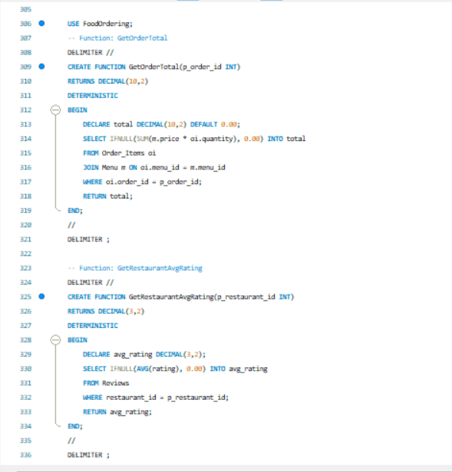

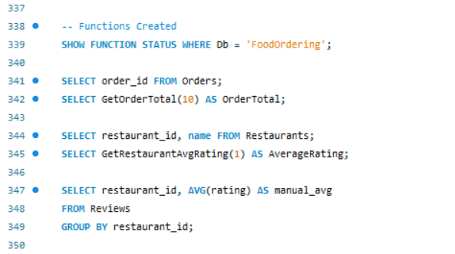

BEFORE:

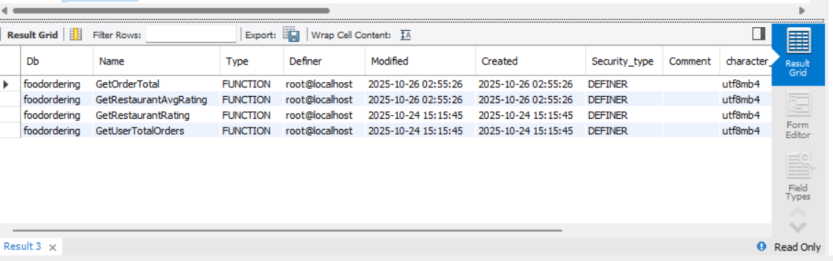

AFTER:

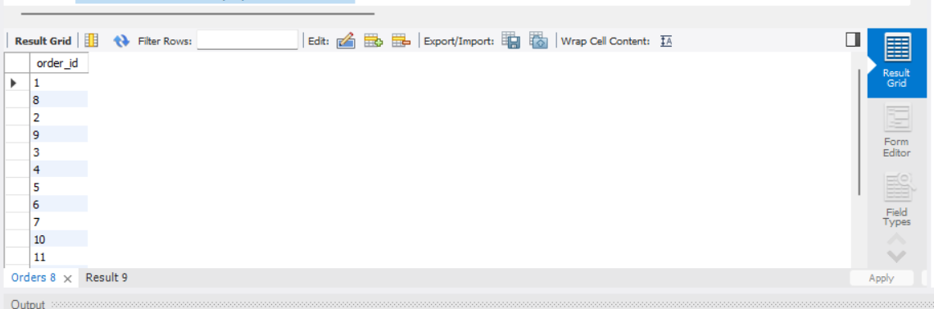

**GET ORDER TOTAL**

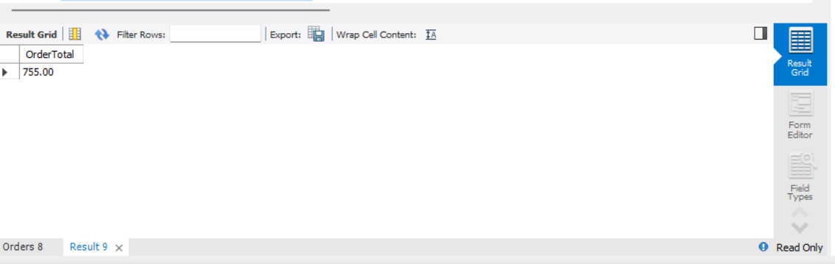

**GET RESTAURENT AVG RATING**

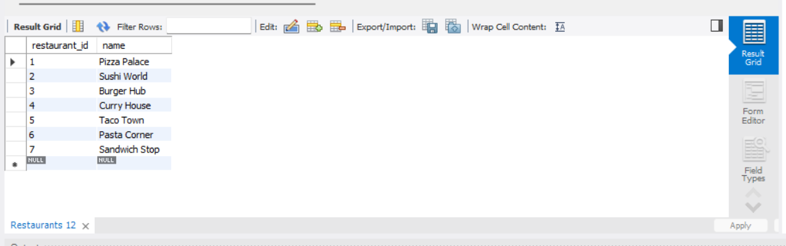

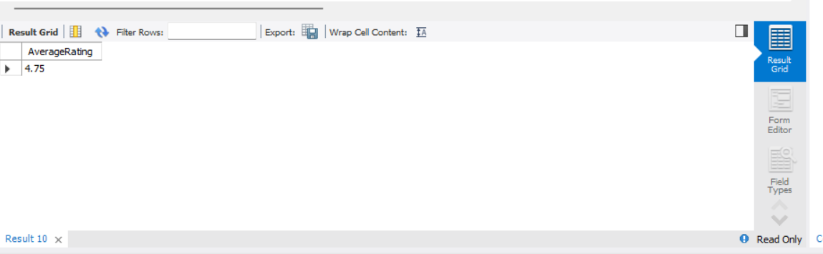

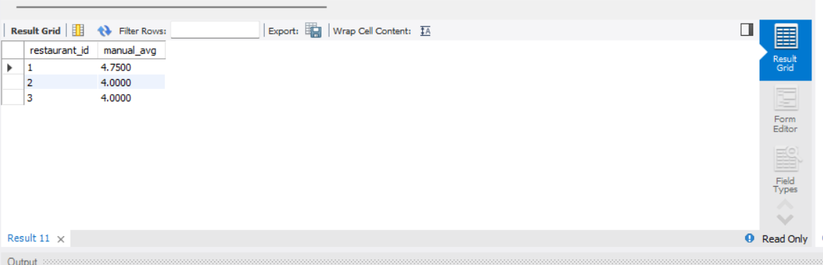

PROCEDURE

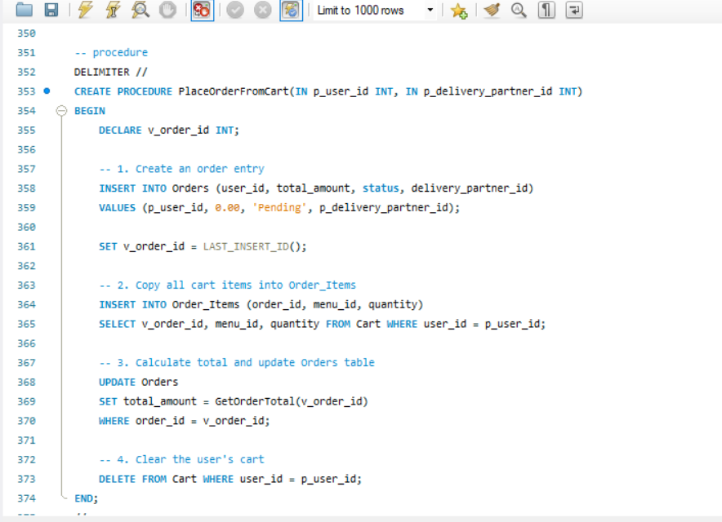

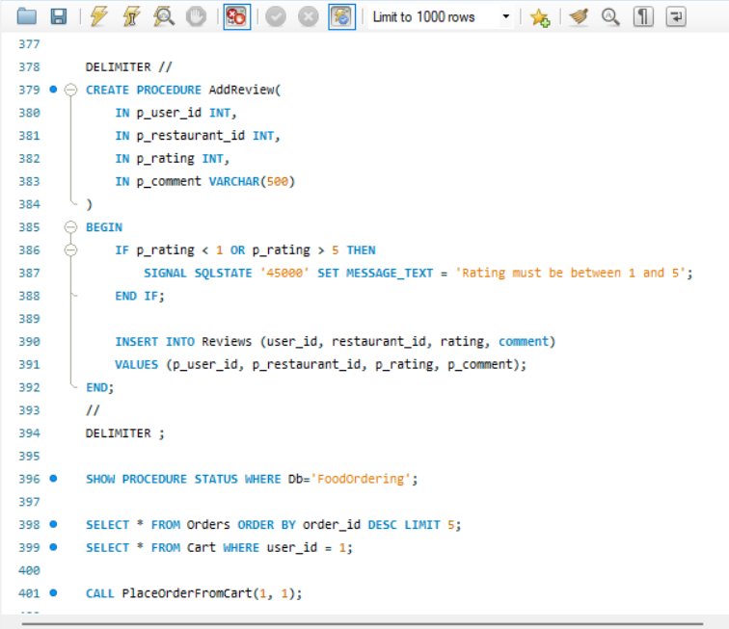

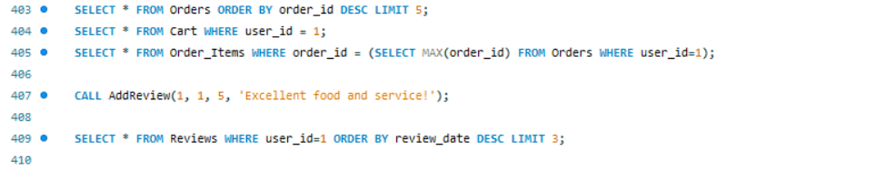

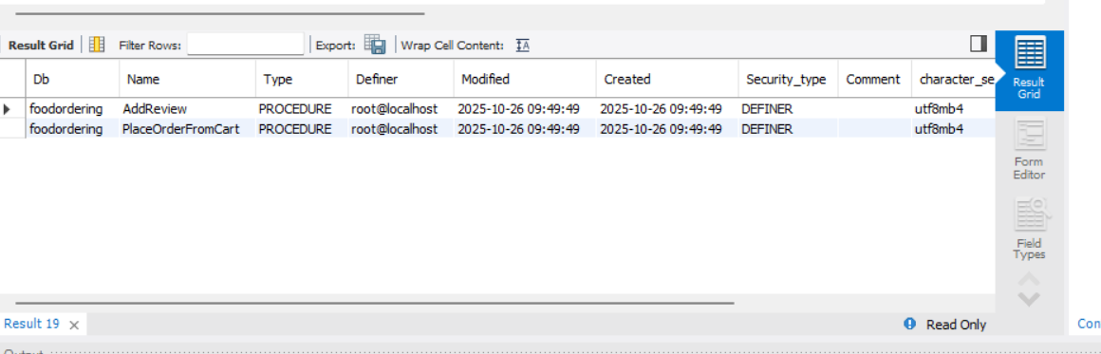

BEFORE

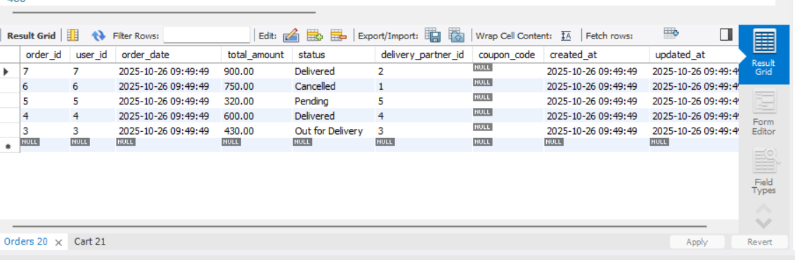

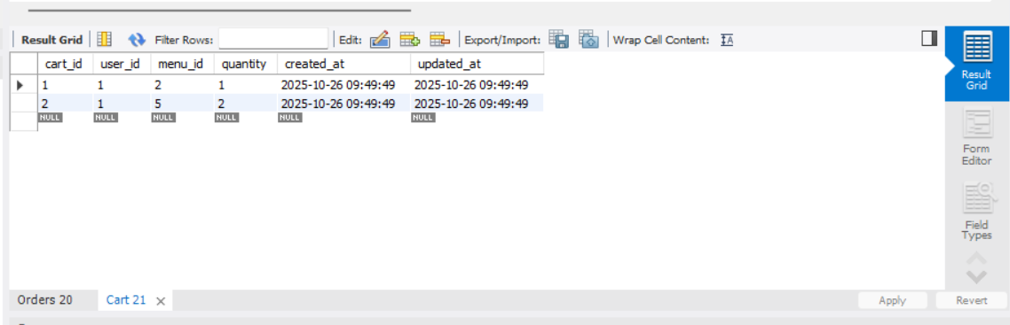

AFTER

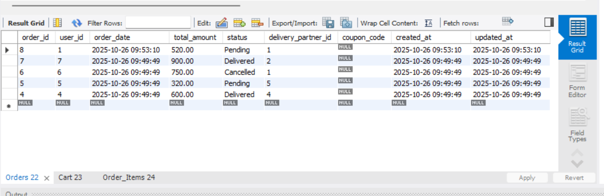

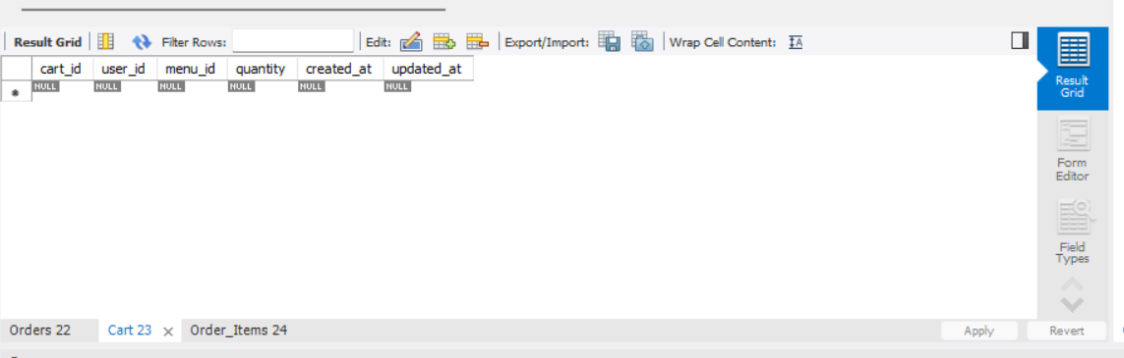

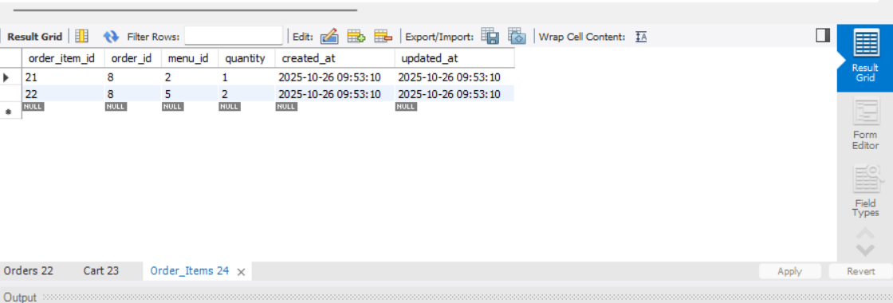

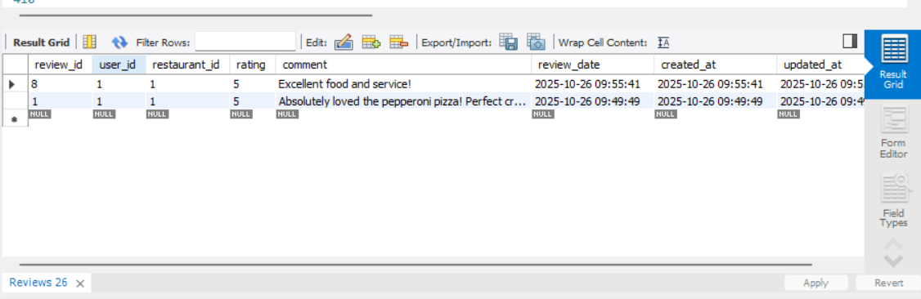

TRIGGERS:

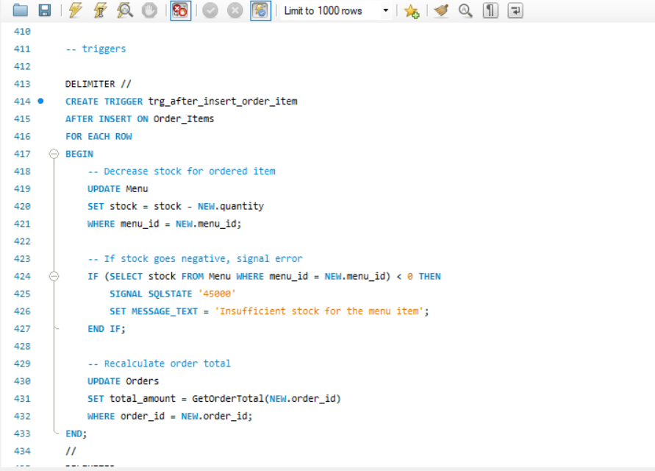

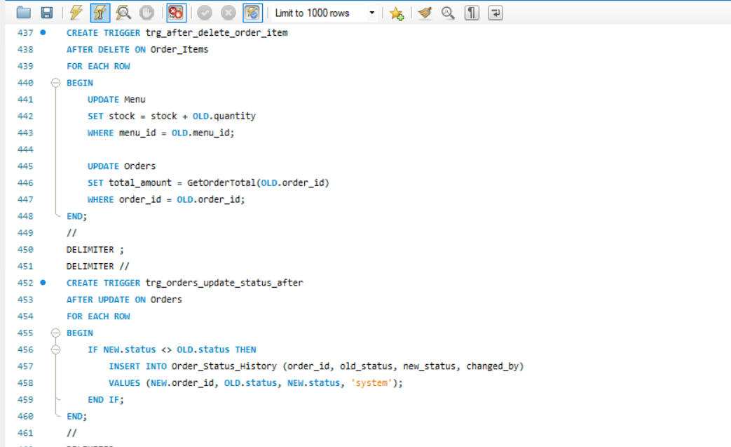

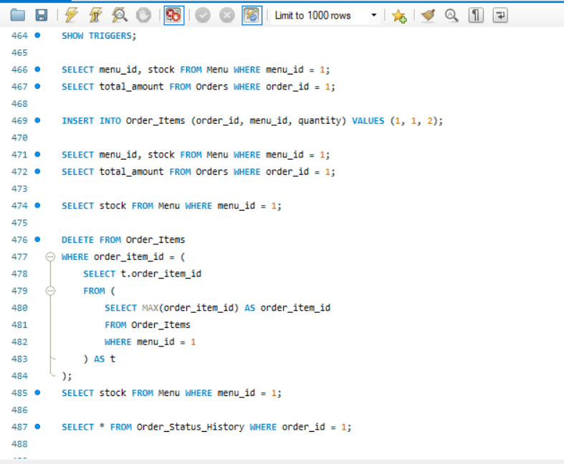

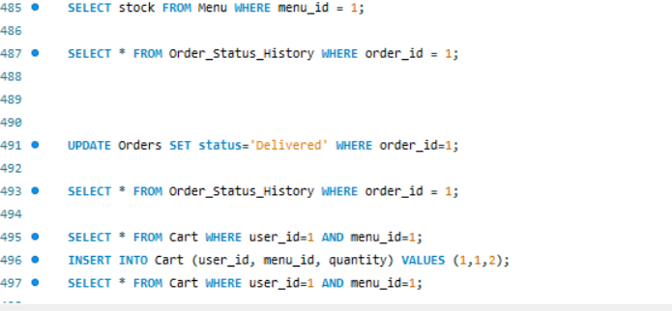

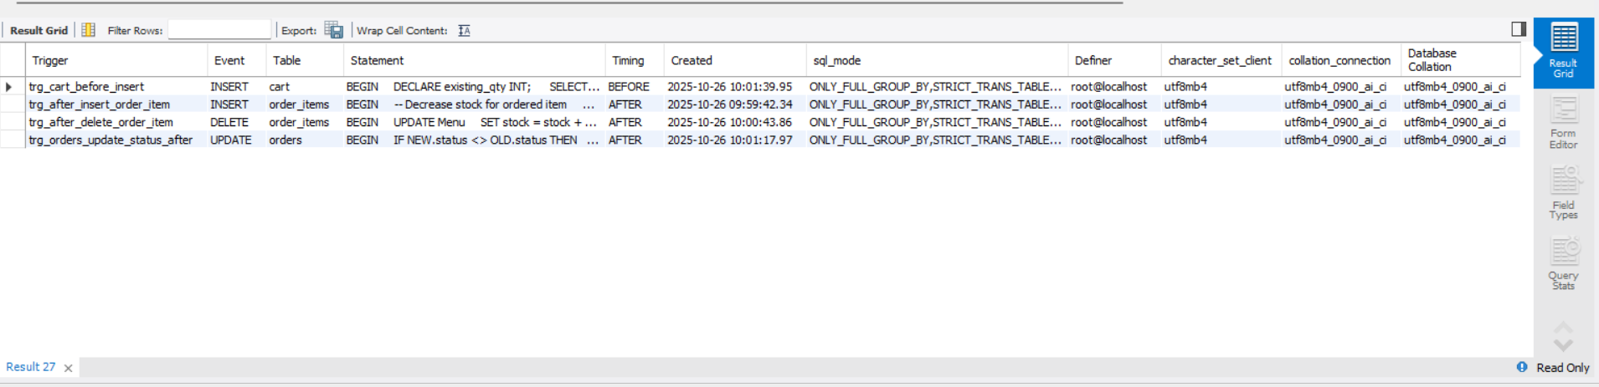

BEFORE

**Stock & Total Update Trigger:**

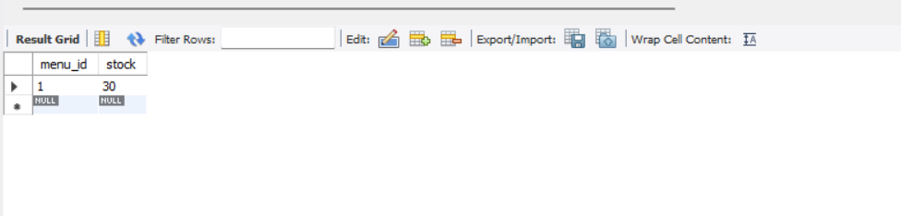

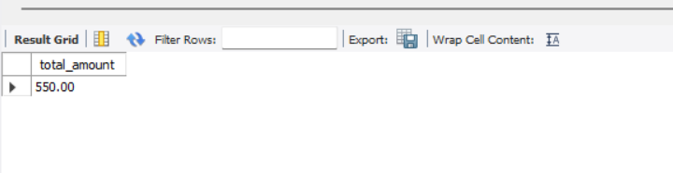

AFTER

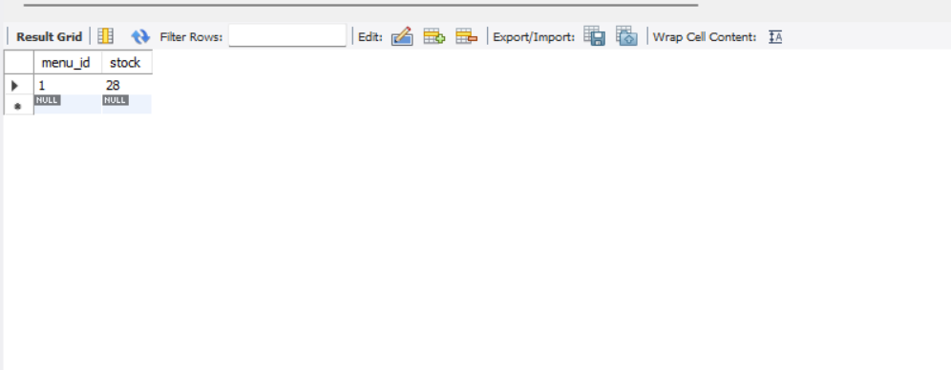

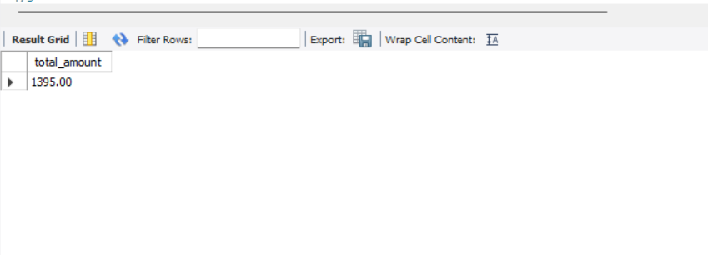

**Delete Trigger**

BEFORE

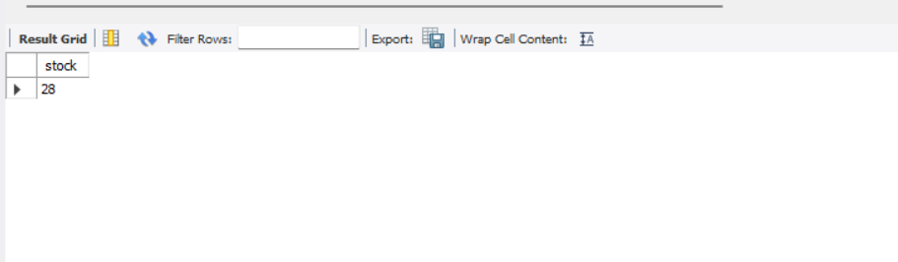

AFTER

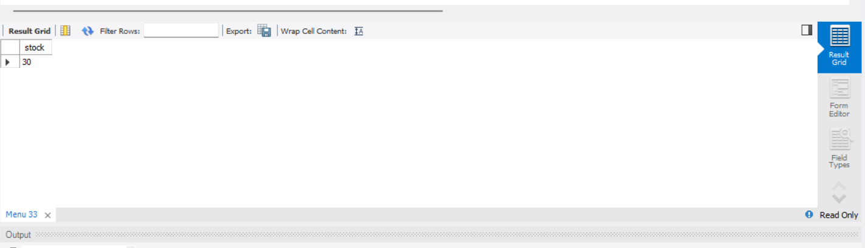

**Order Status History Trigger**

BEFORE:

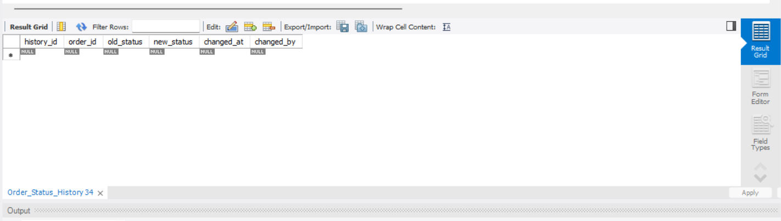

AFTER:

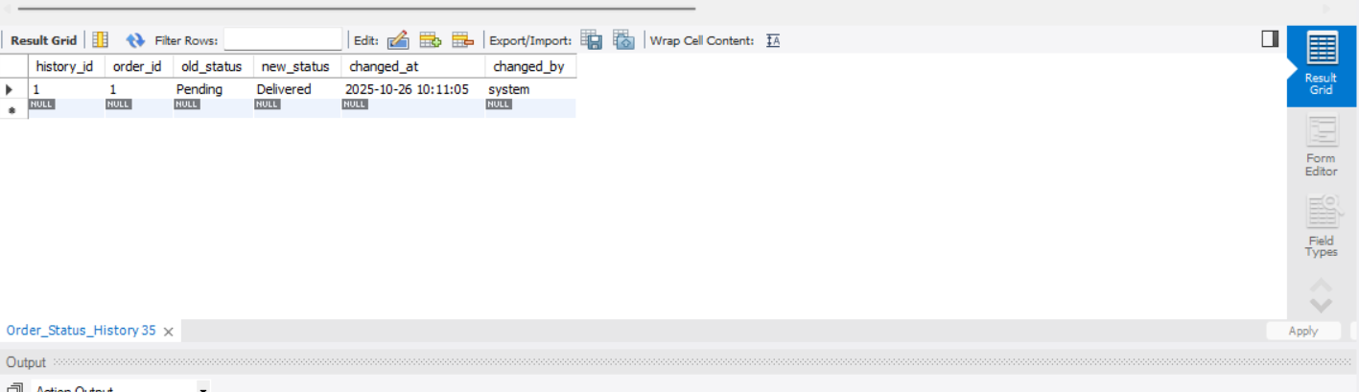

**Cart Quantity Increment Trigger**

BEFORE:

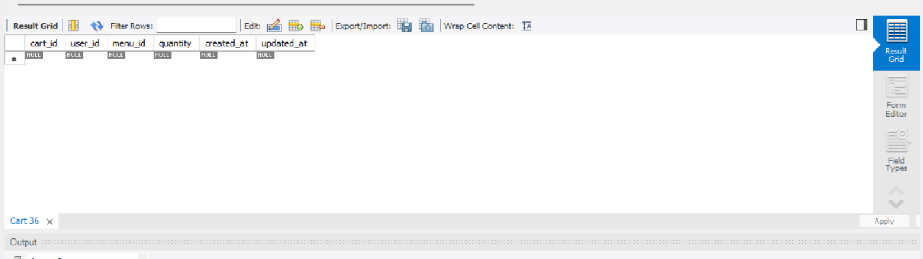

AFTER:

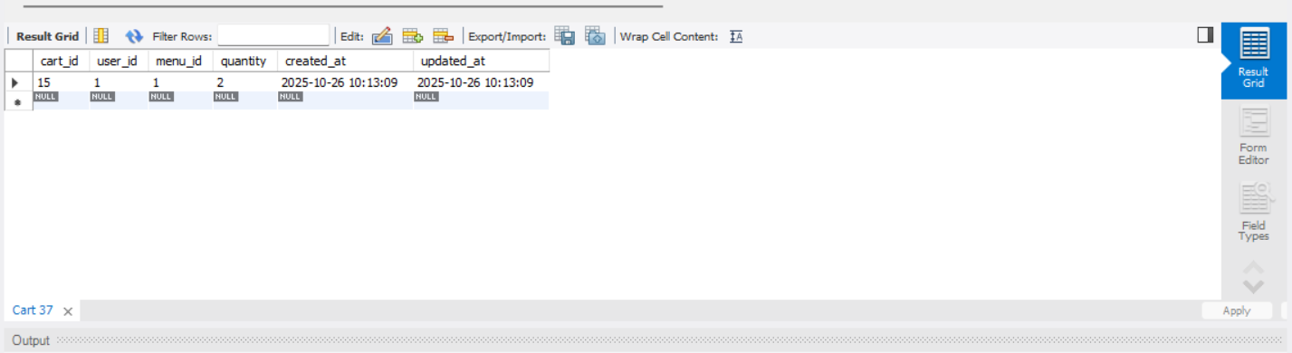

## GitHub repo link:

[https://github.com/sirishivanand24184-png/FOOD-ORDERING-SYSTEM-.git](%20https:/github.com/sirishivanand24184-png/FOOD-ORDERING-SYSTEM-.git)